* 1. **Point Interpolation**

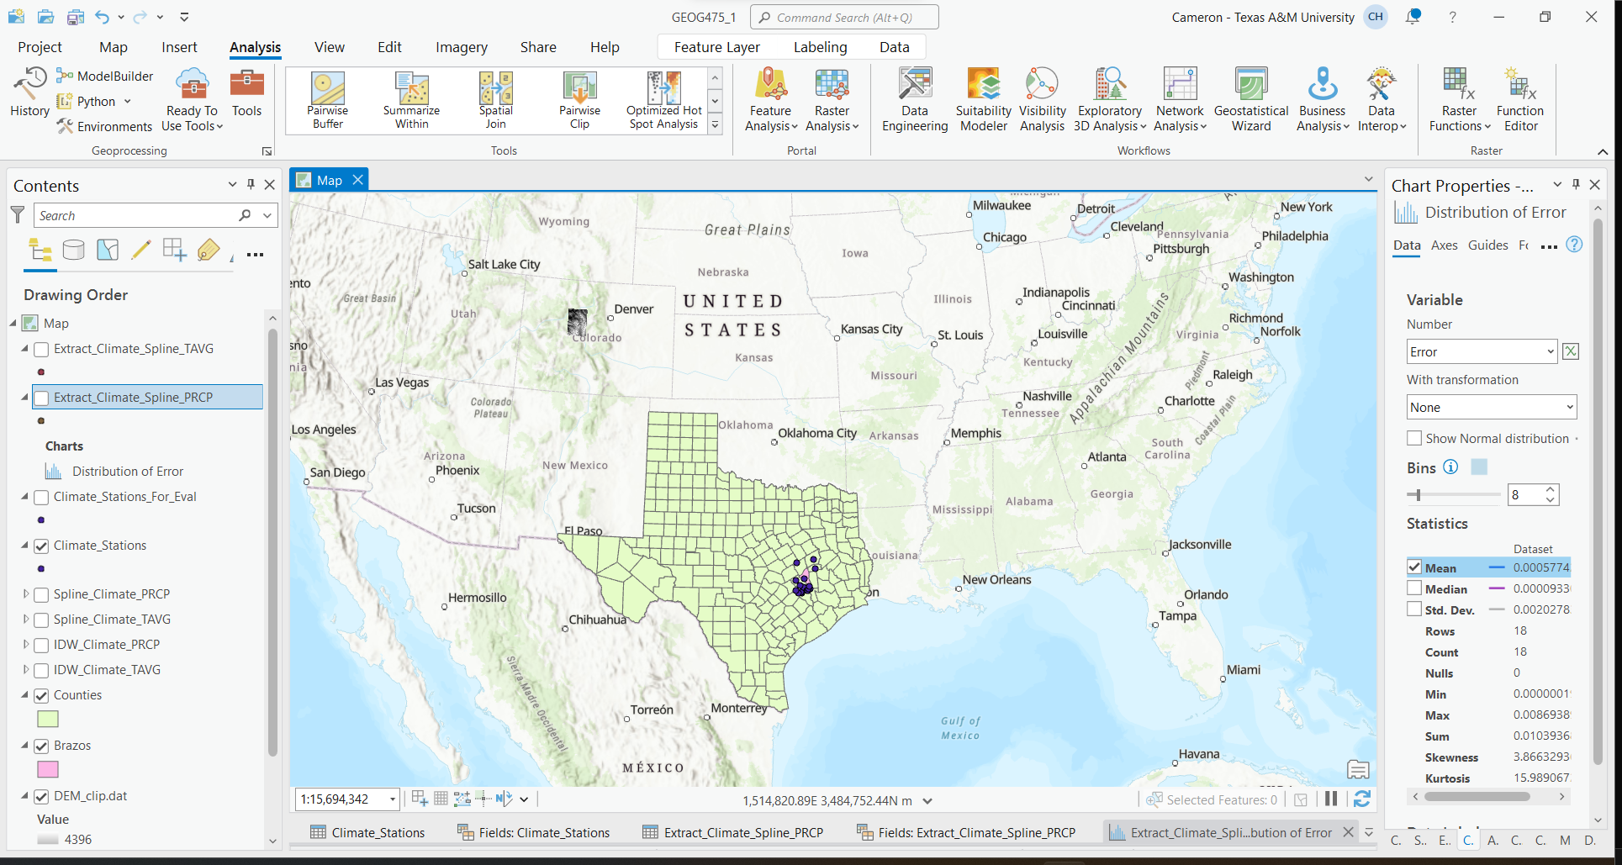

Data was successfully inputted

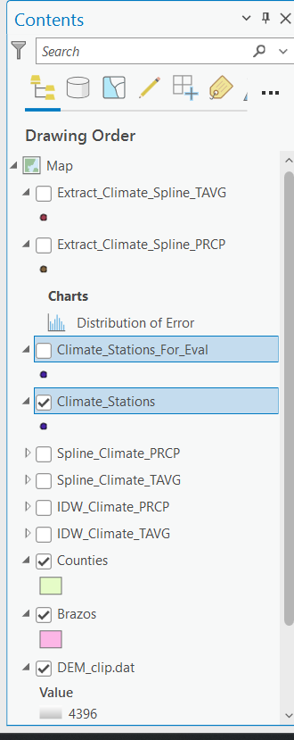

Data was split for interpolation and evaluation

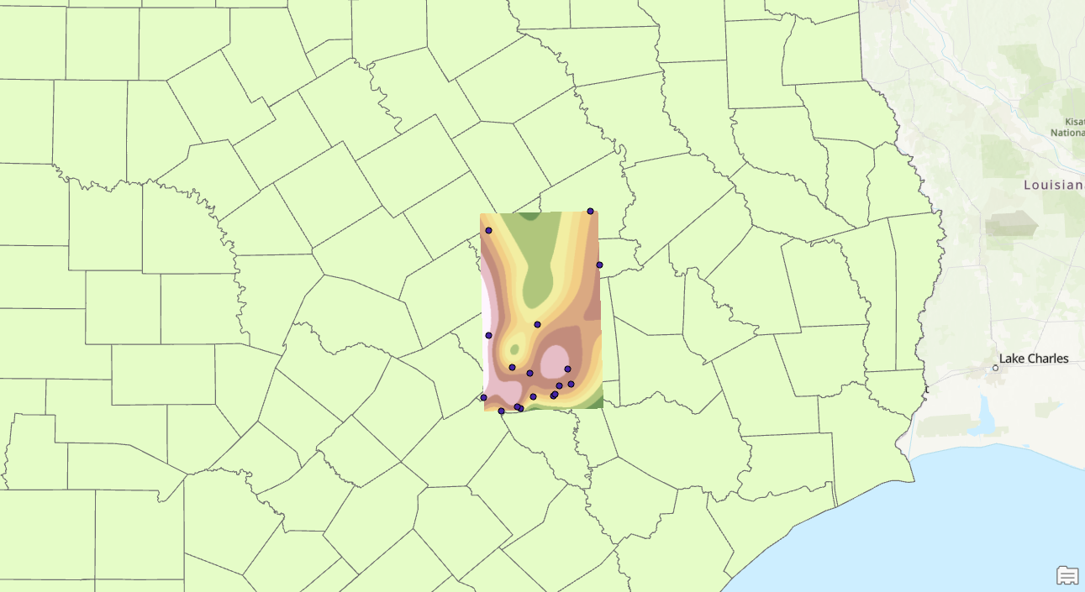

PRCP Spline

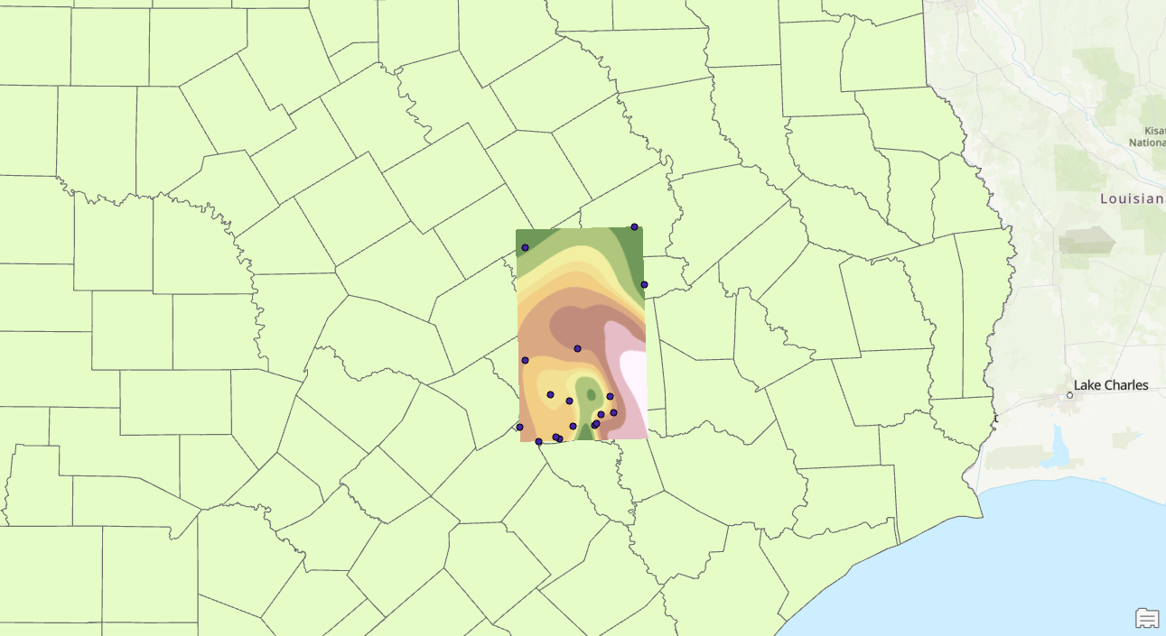

TAVG Spline

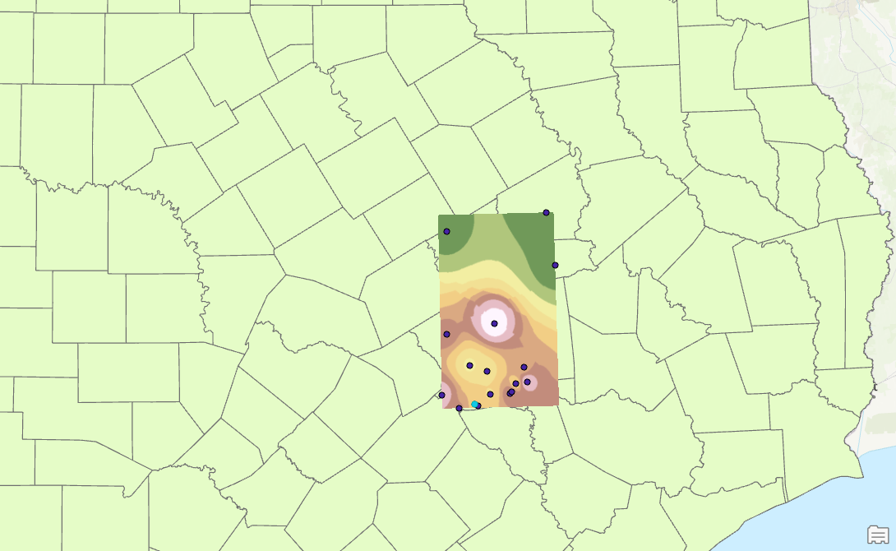

IDW TAVG

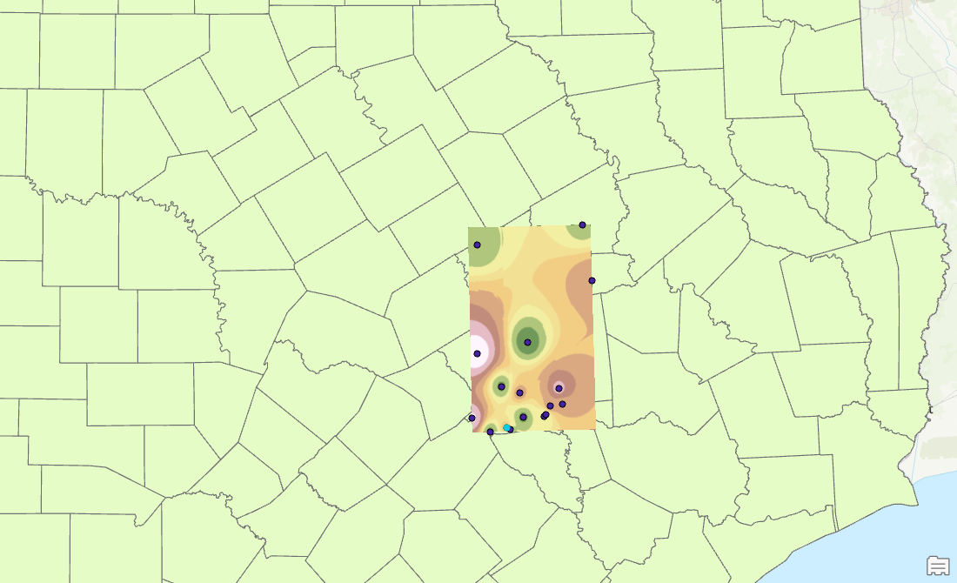

IDW PRCP

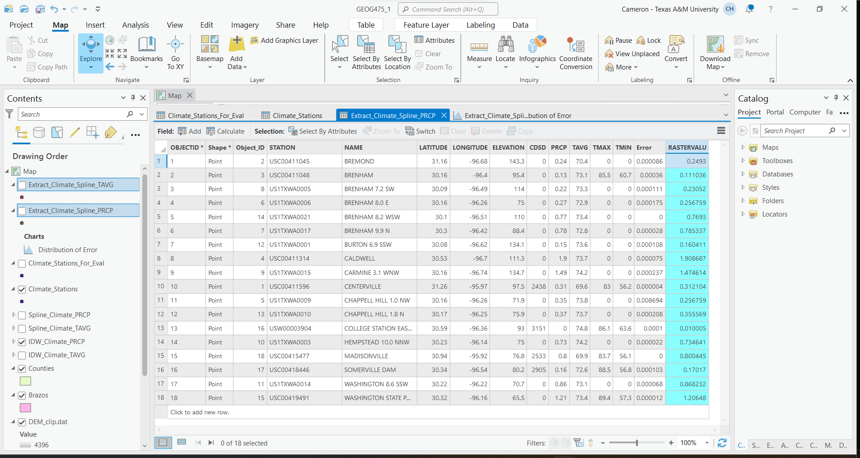

Extract values from interpolated raster’s. In the contents pane, it is shown that the “Extract Values to points” tool was run twice resulting in “Extract_Climate_Spline_TAVG” and “Extract_Climate_Spline_PRCP”. The result is a new field called RASTERVALU, which was used later to make calculations. As can also be seen in this image a field was created for error, and the calculation of (!RASTERVALU! - !PRCP!) * (!RASTERVALU! - !PRCP!) was used for the field. A second calculation was also completed for the TAVG Spline, which I will display below.

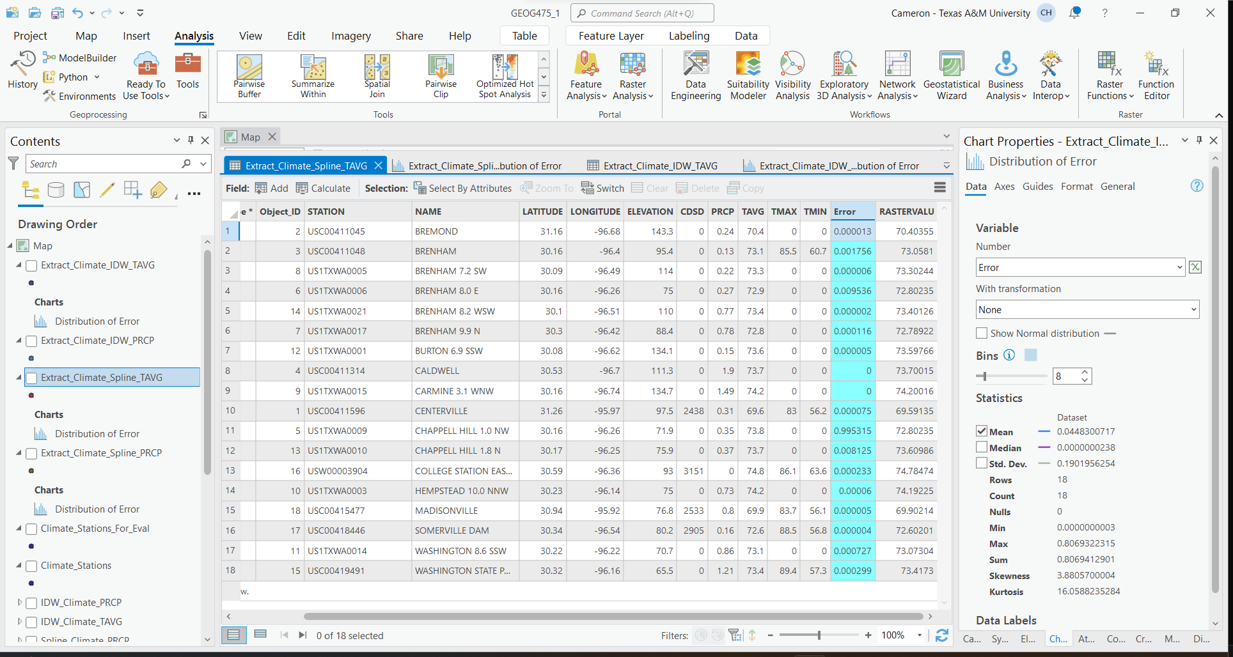

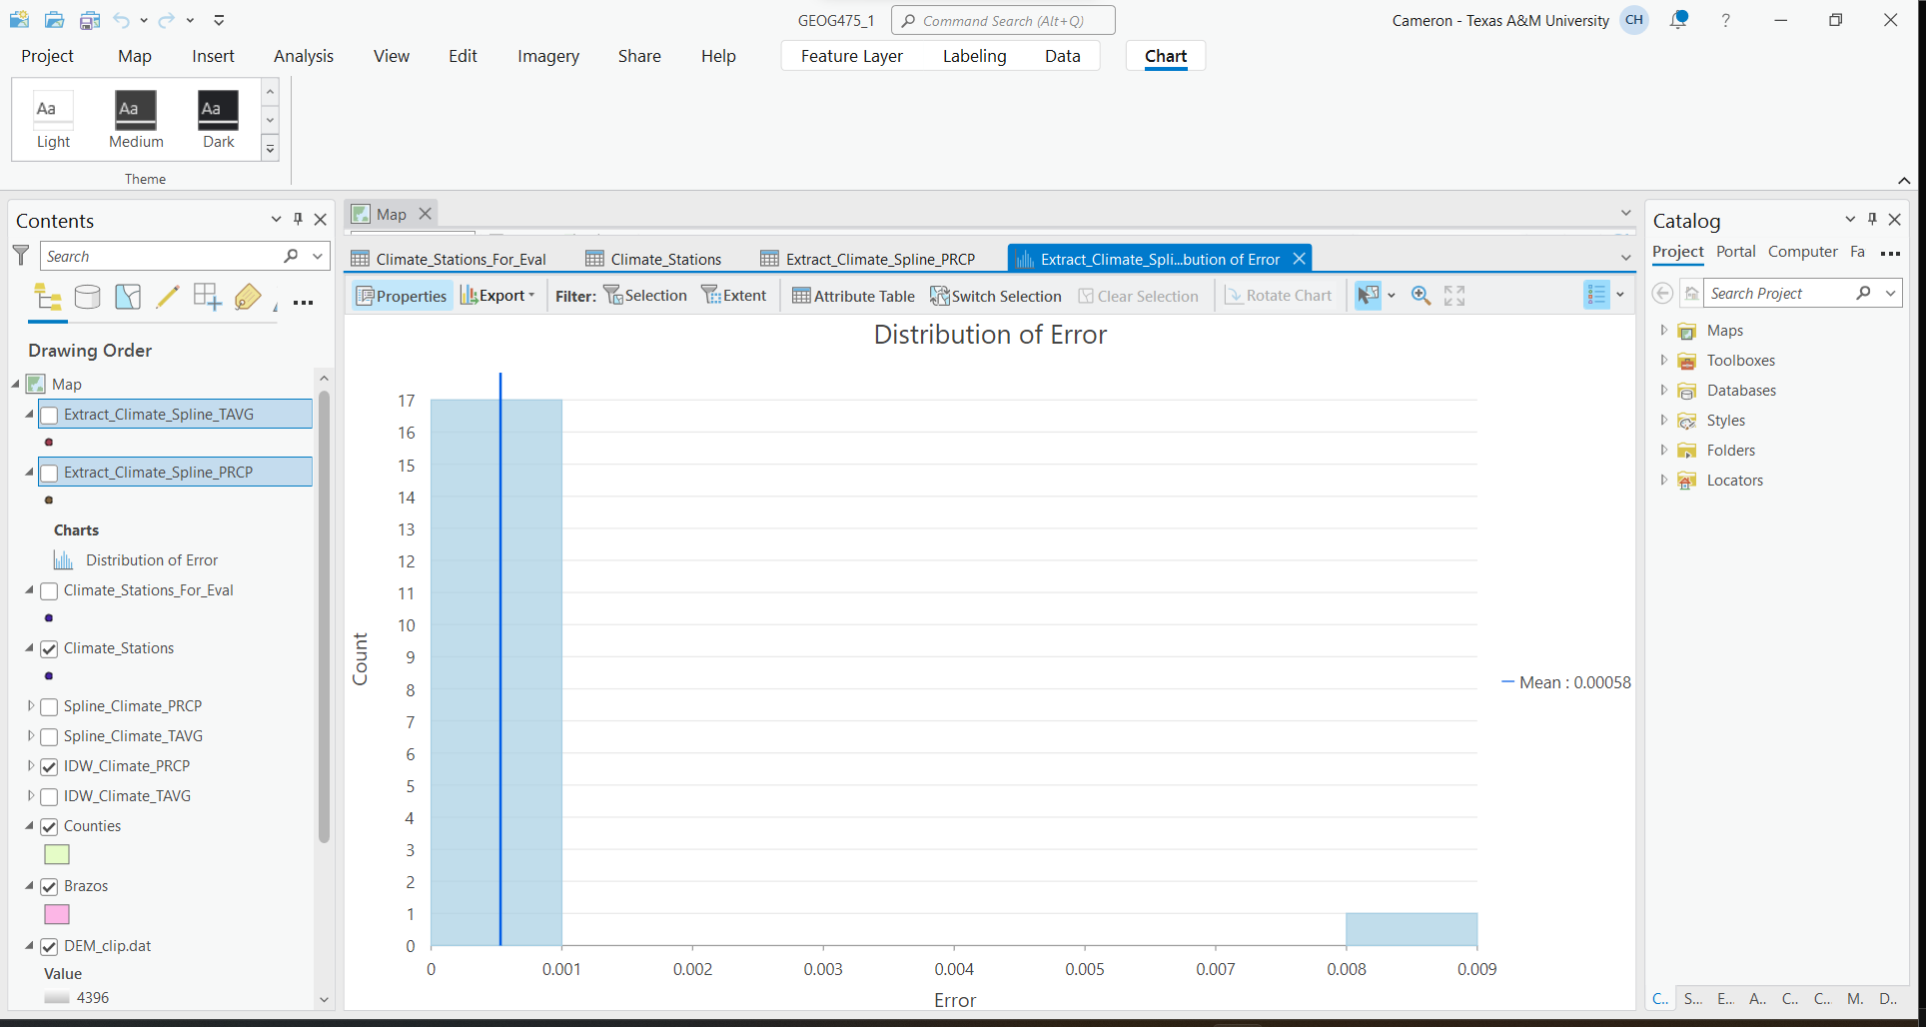Here is the statistics for analysis for PRCP.

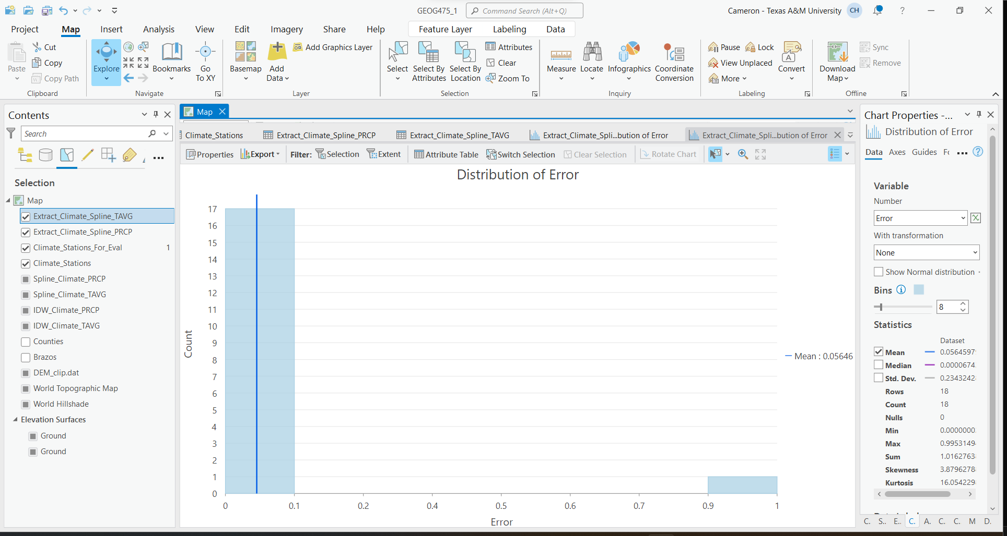

Lastly, here is the statistics for TAVG.

The RMSE for PRCP - Spline was 0.0240297053

The RMSE for TAVG - Spline was 0.2376127078

I will now calculate RMSE for IDW for both PRCP and TAVG

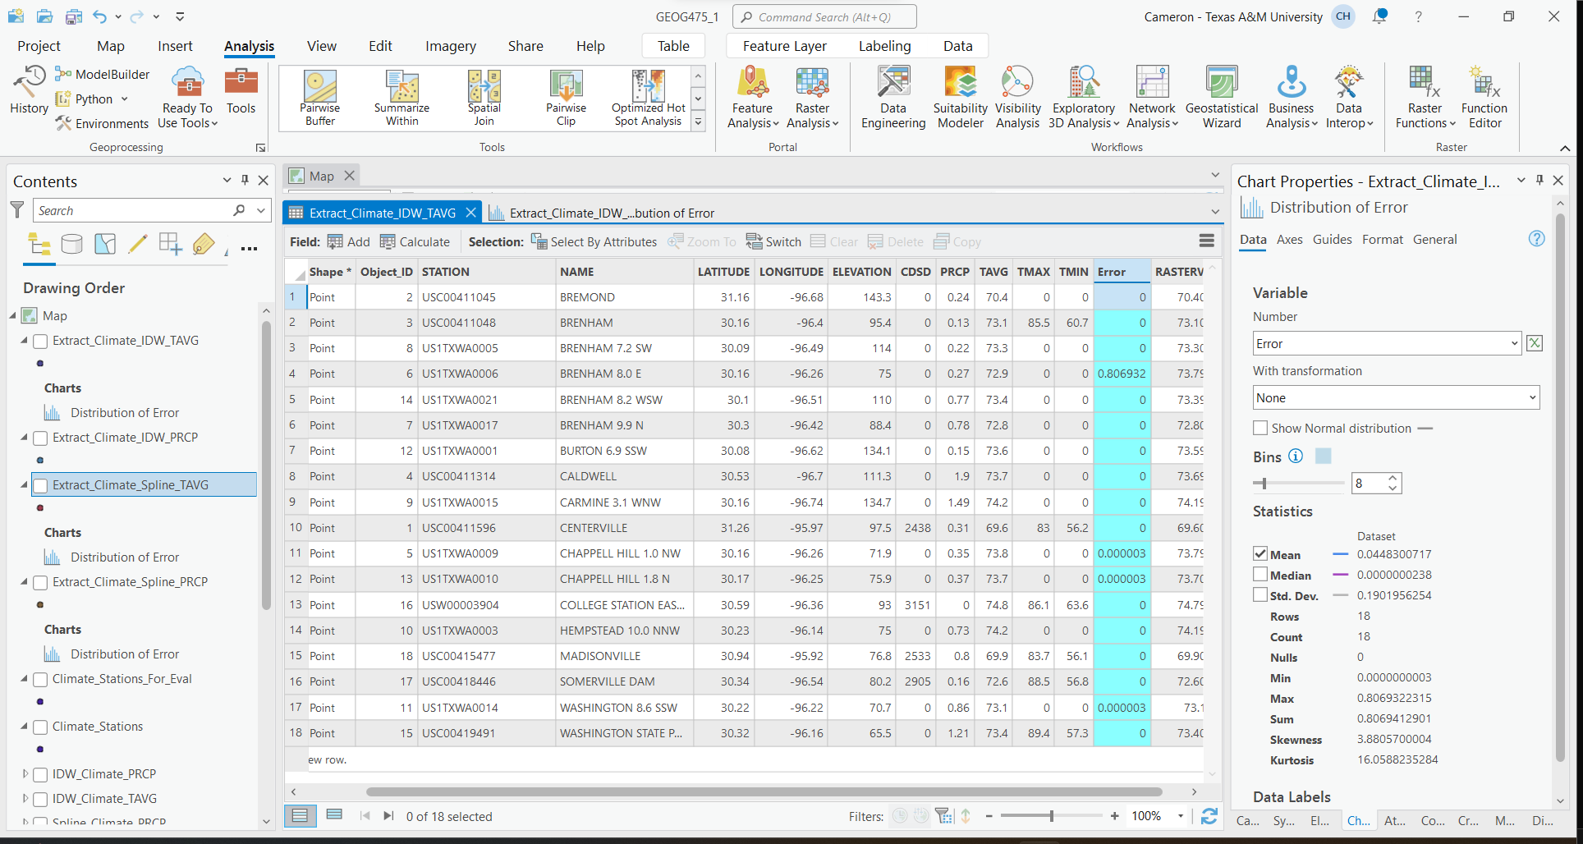

Error calculation for TAVG IDW

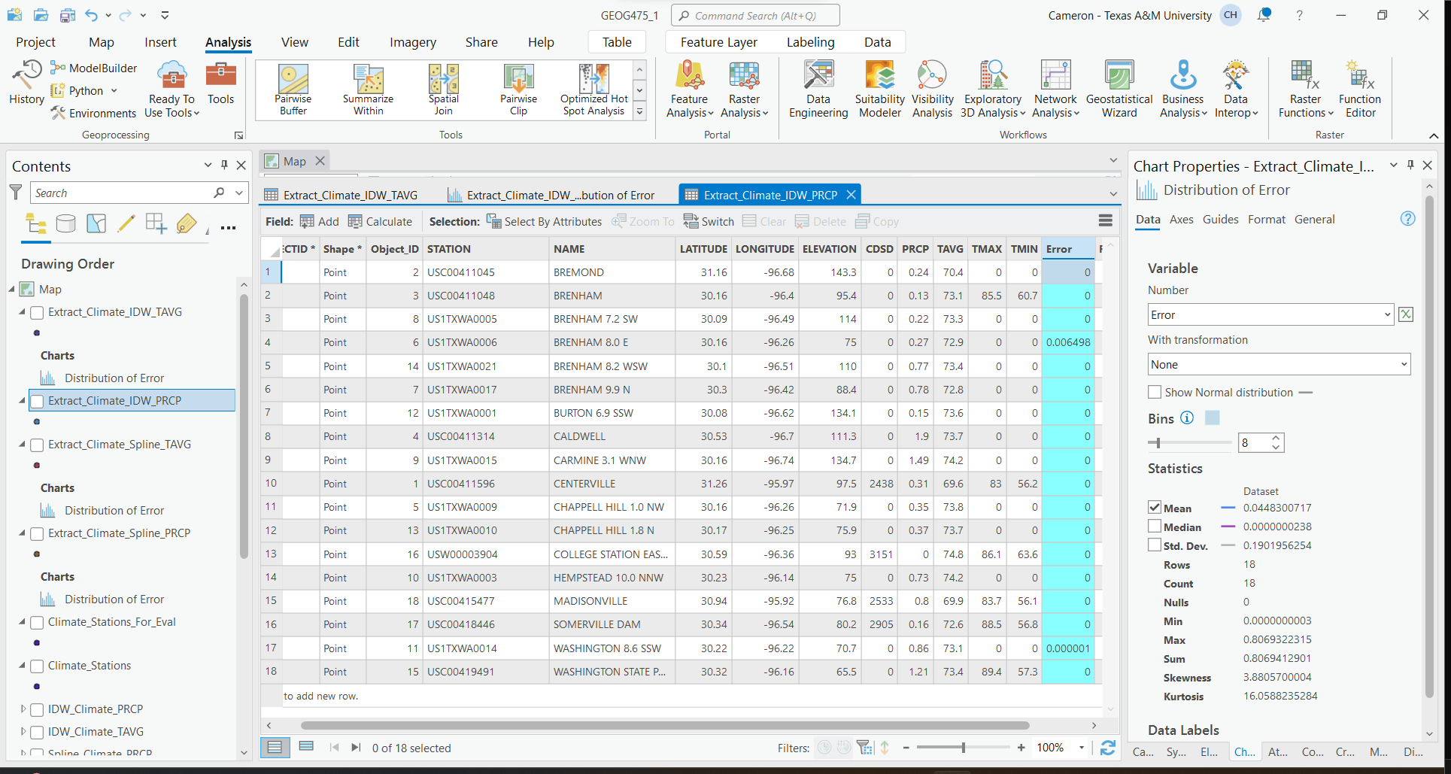

Error calculation for PRCP IDW

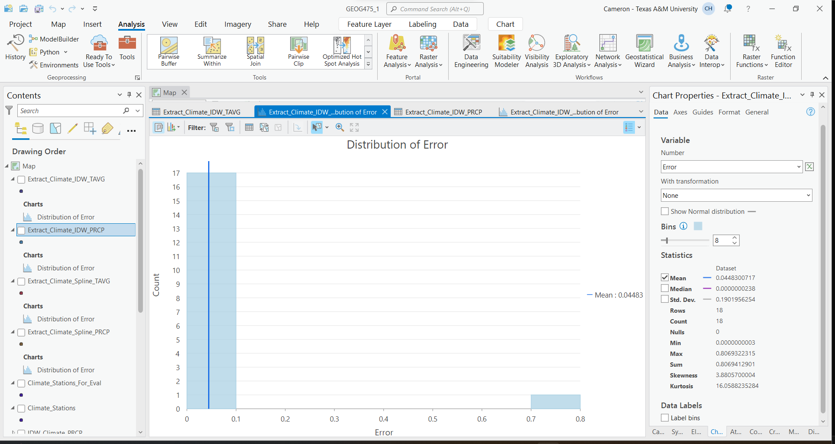

IDW TAVG Statistics

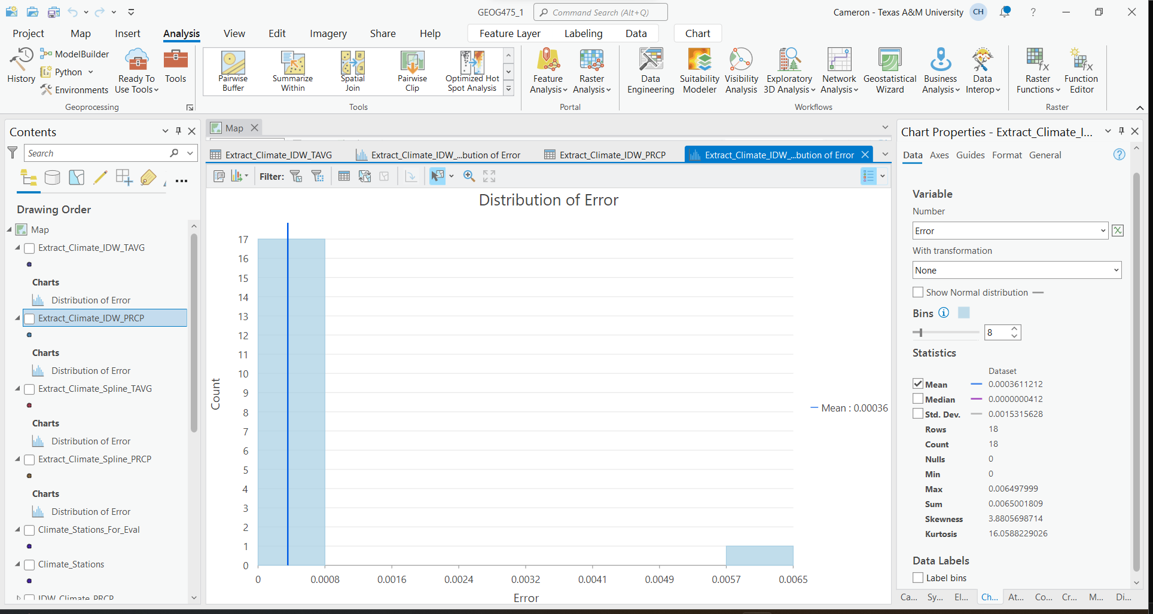

IDW PRCP Statistics

RMSE IDW PRCP : 0.2117311306

RMSE IDW TAVG : 0.0190031882

* 1. **Questions)**

1. *Compare and contrast interpolated precipitation and temperature values for the interpolation algorithms. What was the RMS error associated with each algorithm using default parameter values? Can you explain why each algorithm produced the magnitude of error it did?*

The degree of error for both algorithms, spline and IDW, were very similar. However, the calculated RMSE of the IDW interpolation method was lower for both precipitation and temperature average calculations. The lower RMSE value indicates that the IDW model better fits the data in this question. The spline method showed less precise predictions for the values. In this specific example, the distribution of climate stations is uneven, which causes error when using the IDW method. A similar shortcoming with spline, is that when the distances between control points are large, there is error in calculation. However, the error in these two cases is not tremendous, and the data is good.

1. *Did modification of the input parameters for a specific algorithm modify the RMSE?*

The modification to output cell size greatly increased the RMSE. Changing the size of the output to be significantly larger made the IDW interpolation much more variable, which makes sense being that the scope of the output raster is larger than that of the area of control points, making the data predictions through interpolation less accurate. The same analysis was done on spline interpolation, with the same result.

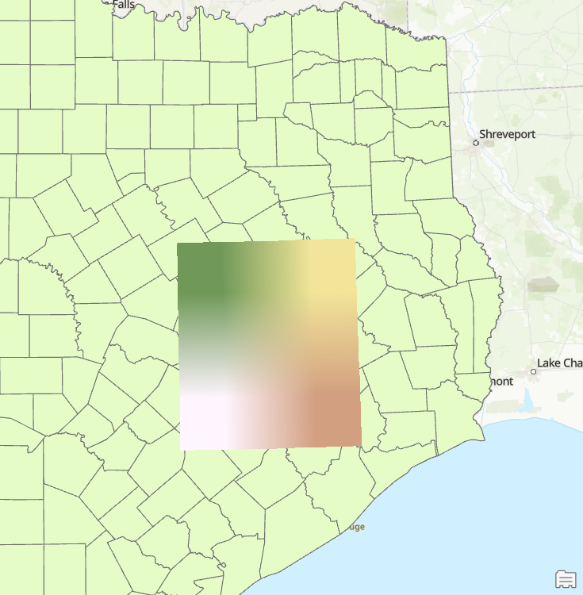

1. *Did different algorithms produce a different spatial distribution of precipitation and temperature? How did you determine if the spatial patterns and magnitudes were different?*

Yes, the different algorithms produced different spatial distributions. This can be seen in two separate ways, visually looking at the raster, or statistically by looking at the error values at the different control points. For precipitation, on the IDW algorithm, the higher and lower values appear to revolve around the control points, where in the spline algorithm for precipitation the values seem to be much more evenly distributed across the raster. A similar statement could be made for the temperature average data. For the IDW interpolation method, there is a clear center point for the map where it has the highest temperature average, whereas the spline algorithm again shows a more spread out interpretation of the data.

* 1. **Raster Resampling**

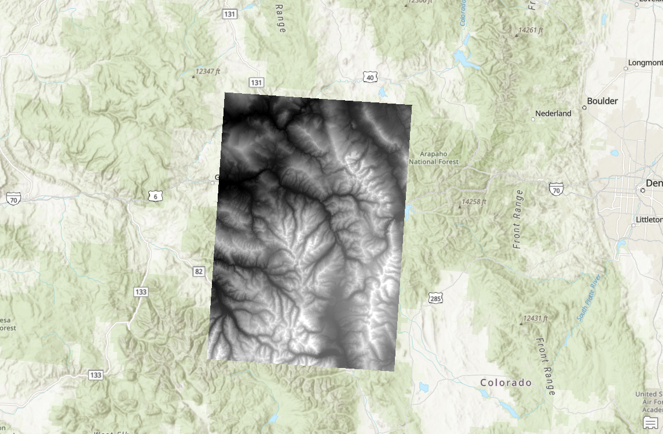

Nearest Neighbor (90 m)

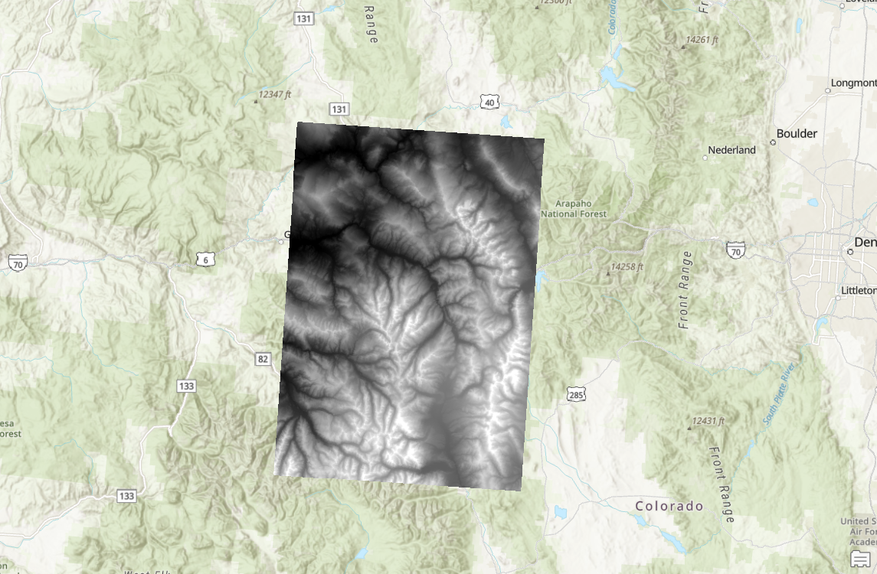

Bilinear (90 m)

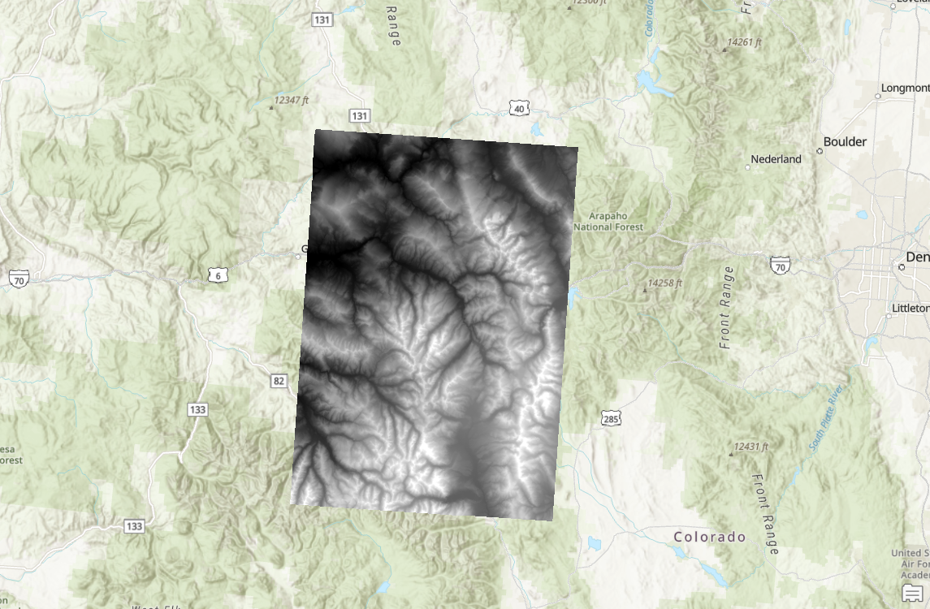

Nearest Neighbor (200 m)

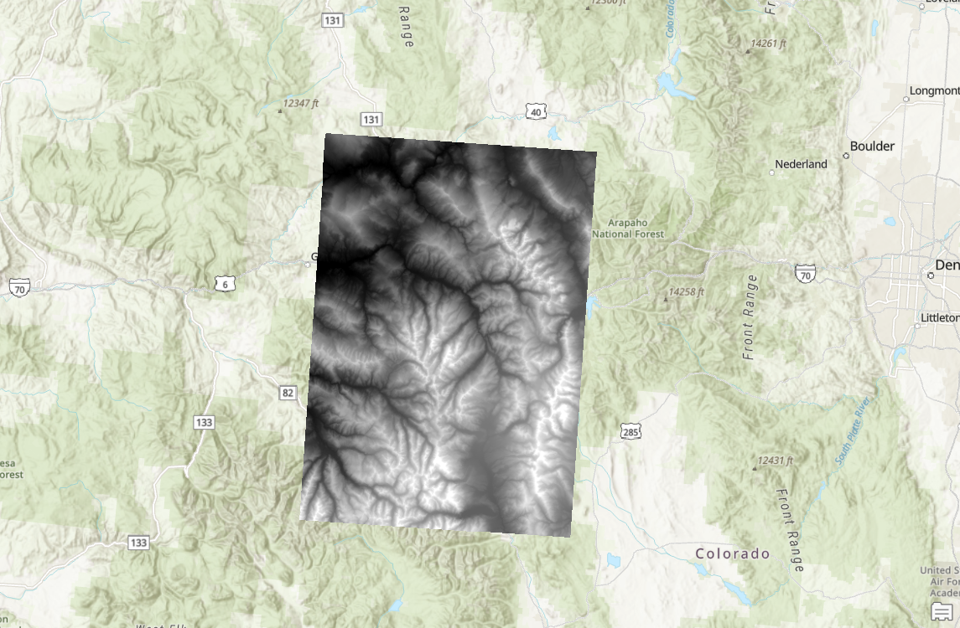

Bilinear (200 m)

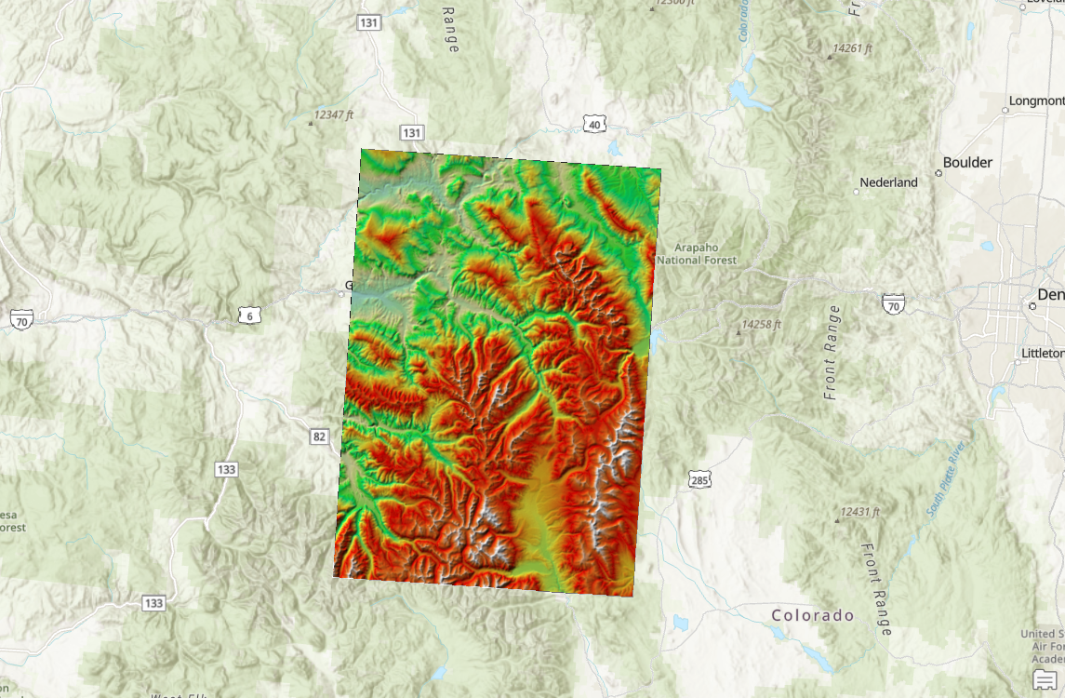

Shaded Relief 200 m, Bilinear

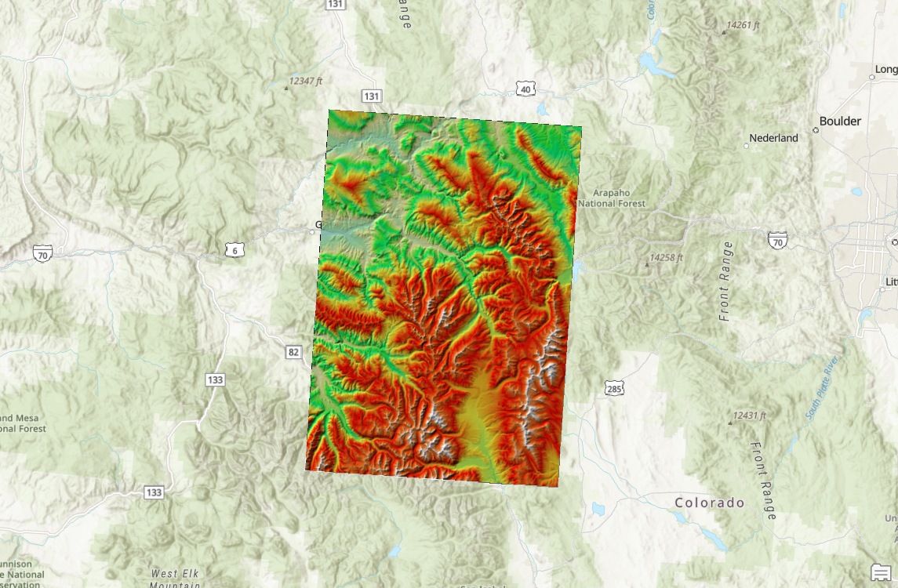

Shaded Relief 90 m, Nearest Neighbor

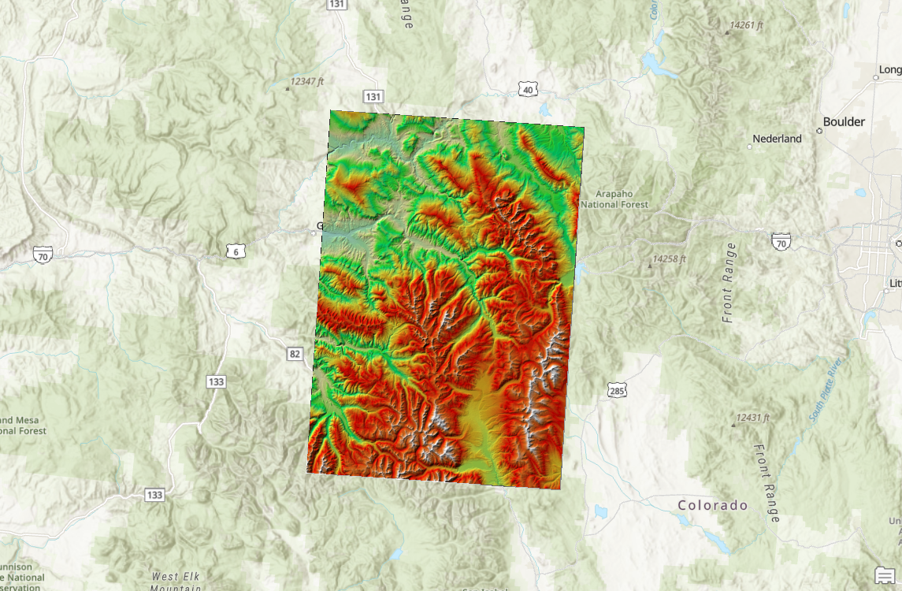

Shaded Relief 30 m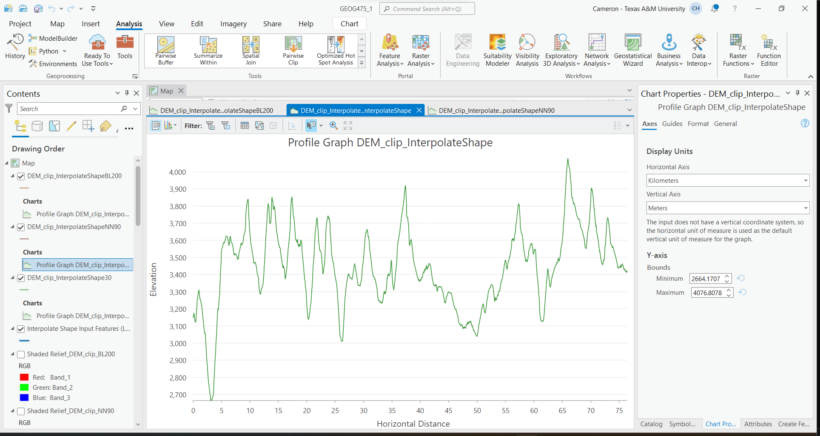

Profile Graph, 30m

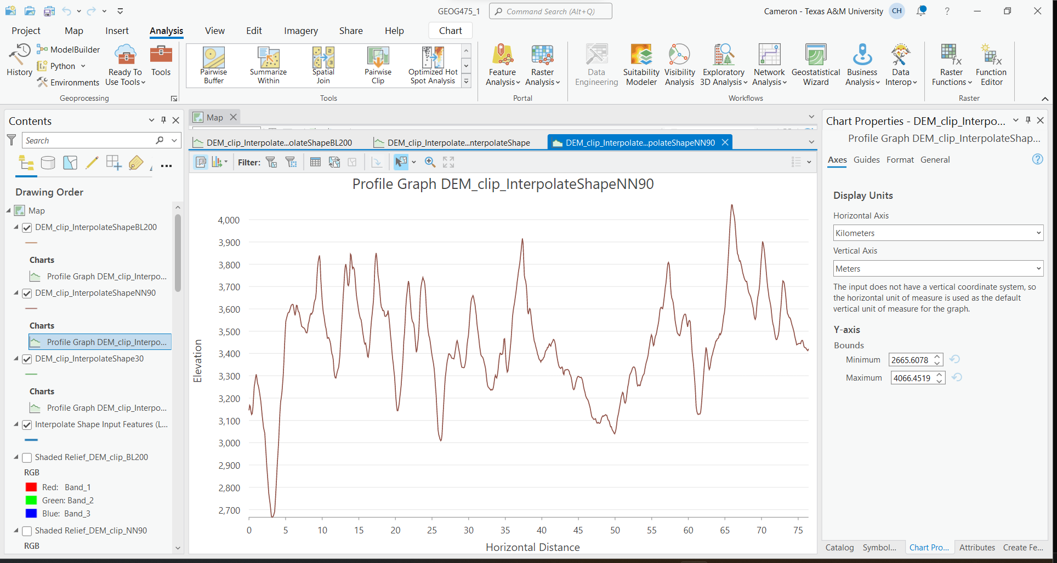

Profile Graph, 90m

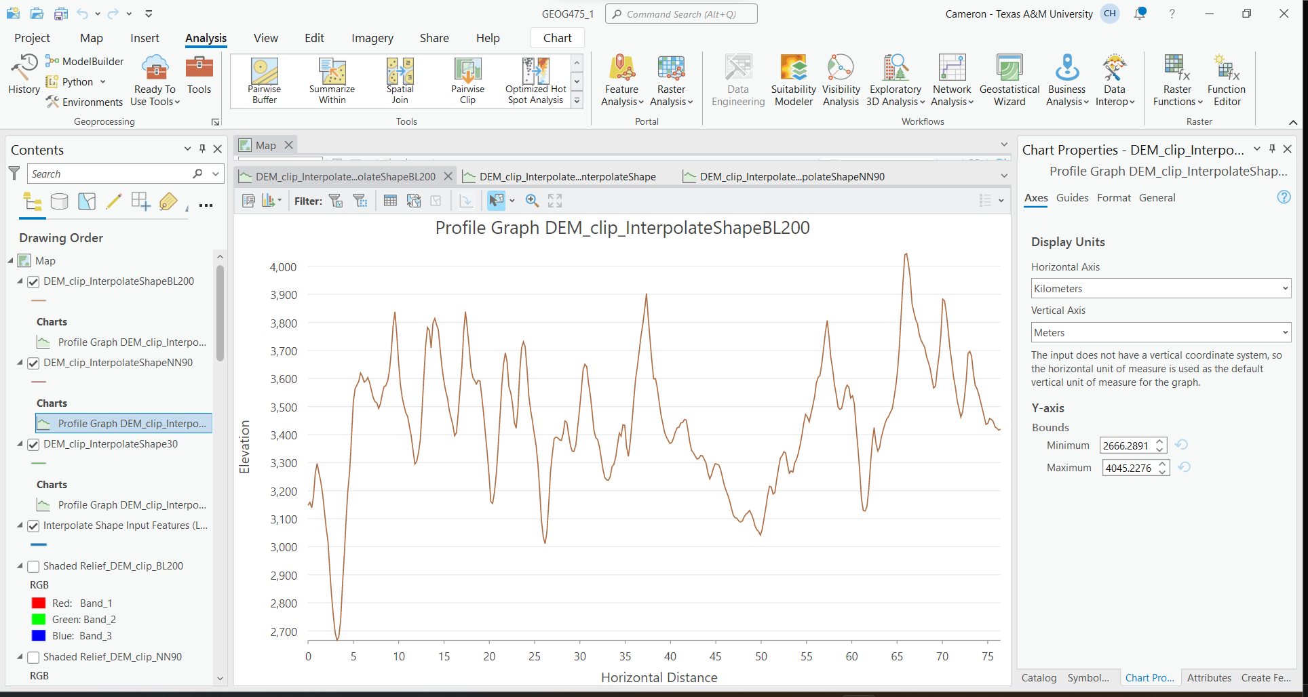

Profile Graph 200m

* 1. **Questions)**

1. *Examine the topography at grid cell scales of 30m, 90m and 200m. You may need to use shaded-relief images to examine the spatial patterns in the topography. Describe how the topography is represented compared to the 30 meter DEM.*

There are a couple of differences between shaded relief and the DEM visualization of the elevation, as well as differences between the shaded relief images on different scales. The DEM shows the higher points in elevation on a scale that shows low points in black, and high points in white, as a default. The shaded relief images used a different coloring scale that shows cooler colors, such as blue and green as low elevation points, and warm colors such as red, yellow, and white as higher elevation points. The vaster color scale used on the shaded relied images makes the change in topography much more apparent, where the DEM, at its default settings looks blurrier, and difficult to interpret the changes in elevation.

1. *Compare and contrast the DEMs at a particular scale generated using different interpolation algorithms. Does the type of interpolation algorithm at a particular scale influence the nature of the topography depicted in the shaded-relief images?*

Differences were more noticeable at different scales than others. At 90m resolution, it was clear that the nearest neighbor interpolation method was the better method when viewing the DEM resample. What appears to be streams, or creeks running off the hillsides were much more clearly defined using nearest neighbor at the 90m resolution. For the 200m resampling resolution, finding clear differences between the bilinear and nearest neighbor methods was difficult. The two images were rather blurry. This makes sense being that the resolution was so low. Using shaded relief imagery further confirmed my point above, that the 90m resolution was far easier to interpret than the 200m resolution image. Above all else, the best image for interpretation was the 30m resolution image, however it must be noted that over a larger scale, this resolution would take plenty of storage, as well as time to analyze.

1. *Compare and contrast the interpolation algorithms that were used to generate topographic profiles. Do this for all two grid-cell scales. Which algorithm is most accurate? How did you determine this? Can you produce quantitative evidence?*

The most accurate method was nearest neighbor, qualitative evidence shows that nearest neighbor produced a clearer image between the two. However, this question asks to address quantitative evidence. After reading on the subject, it became evident that bilinear interpolation was the more effective method over this scale compared to nearest neighbor. Quantitatively, this can be seen when the resampling was conducted at the 200m resolution, where the nearest neighbor method moved the scale by 12 meters total, whereas bilinear only moved the scale by 10 meters in total.

**1.3 Spatial Interpolation Algorithms**

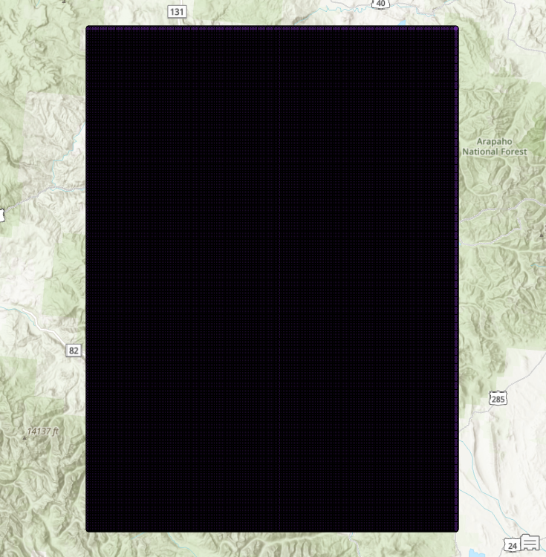

Fishnet created

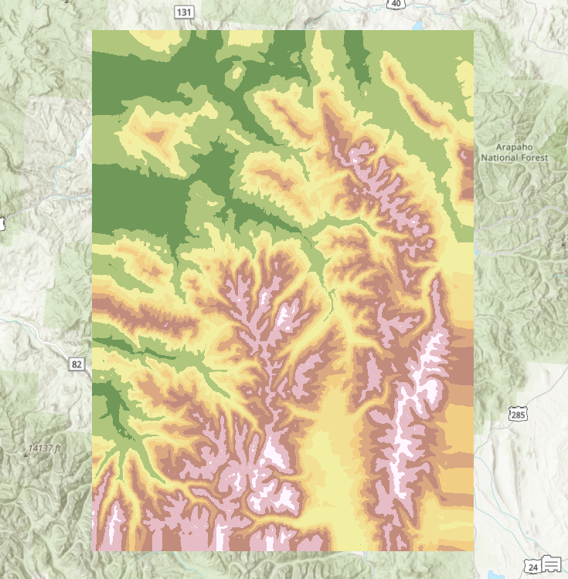

Generated DEM

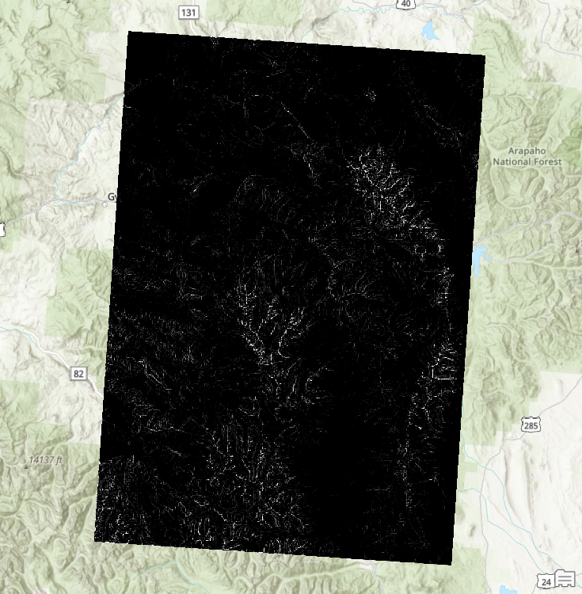

Square raster

The mean of the raster was 473.5881385141673, compared to a mean of 3036.9947040334 on the original, provided raster.

The RMSE was 2563.077, this was calculated by subtracting the mean from the interpolated raster, by the original raster mean, then squaring, and then lastly taking the square root.

* 1. **Questions)**

1. *Compare and contrast the results from the IDW algorithm to the original data. Did the use of different parameter settings influence the results to any degree? Did different parameter settings generate different spatial patterns in topography? Was there a difference in terms of the global RMSE?*

After interpolating, and manipulating the raster, there were differences in the data. After interpolation the raster was less accurate. After computing the RMSE, there was a glaring quantitative difference in the data. Visually, it can be concluded that the provided DEM is better for analyzing the surface in question. Changing the parameters manipulated what was produced through the IDW interpolation method. Different parameter settings did influence the results, as was done in part 1 of this lab. The output cell size was manipulated which impacted the results greatly. This is to be expected as when the output size is increase, the accuracy of the produced data becomes less accurate, as there is more interpolation being done.

1. *Compare and contrast interpolation results using the cubic spline algorithm. Did the use of different parameter settings influence the results to any degree? Did different parameter settings generate different spatial patterns in topography? Was there a difference in terms of the global RMSE?*

Spline is the better method here. The RMSE of the spline was 25.83 which shows that the discrepancy in values using the cubic spline interpolation method was lower than that of the IDW interpolation method. The RMSE of IDW was significantly larger than that of the RMSE of Spline, which suggests that this interpolation method better fit in resampling with the provided raster.

1. *Which algorithm produced the best results? How did you determine this?*

The Spline interpolation algorithm produced the best results. Throughout the lab, the Spline method has produced lower RMSE values, which suggests that the data produced is more accurate, and that the method works better. However, visually I disagree with my above statement after seeing streams and peaks earlier in the lab, the numbers suggest that Spline is the best method that was used in this lab.

1. *If the sampling of the points from the original DEM were closer together or further away from each other, do you think that the same algorithm would produce the best results? If you think this is so, would you use the same parameters? If not, explain why.*

If the points were closer together or further apart, both methods would increase in accuracy, however neither would gain an advantage over the other. Both IDW and Spline increase in accuracy as points are closer together. IDW would increase in accuracy because there would be less area that needed interpreting, IDW is best used when the points are closer together. As it pertains to the Spline interpolation method, the results may become less accurate depending on the terrain that is being analyzed. If the DEM covers an area with little change in elevation, Spline would not be the best method. However, where this DEM is covering has much change in elevation, so Spline would also work better with more points to reference, because spline is best used when the points are close to one another, and there is rapid changes in the values.

1. *Knowing what you now know, how would you produce the best interpolation results for the climate data that you worked with earlier (don’t do the work, just describe what you could do differently to produce better results). Be sure to justify the reasons for your decision.*

For climate, there are two correct answers after working through this lab. My answer is that it depends. If the project in question was working with data from College Station, and its surrounding area in the Brazos valley, IDW would be the interpolation method that I would choose. This is because for both the average temperature and the precipitation values, the RMSE was lower than that of Spline. However, if I were working with data on the Hawaiian Island of Maui, I would use Spline. As was seen in part 3 of this lab, where the variable is more extreme, Spline worked better. That was proven through RMSE values. So, for an Island like Maui where one side of the island sees plenty of rainfall annually, where the other side is rather dry, and beaches that average temperatures in the 80s, with the peak of the island reaching below freezing temperatures often, Spline would be the best method.